Tutorial – 5

**Aim:** Write a shell script to find factorial of given number n.

**Code:**

#!/bin/bash

echo "Enter any number: "

read num

result=1

while [ $num -gt 0 ]; do

result=$((result * num))

num=$((num - 1))

done

echo $result

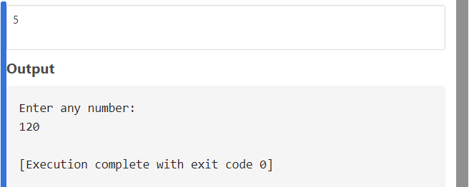**Output:**